LAB TASK 1:

#include <iostream>

using namespace std;

int main(){

int sum,z;

cout<<"enter the number";

for(int i=0;i<=10;++i){

cin>>z;

sum+=z;

}

cout<<sum;

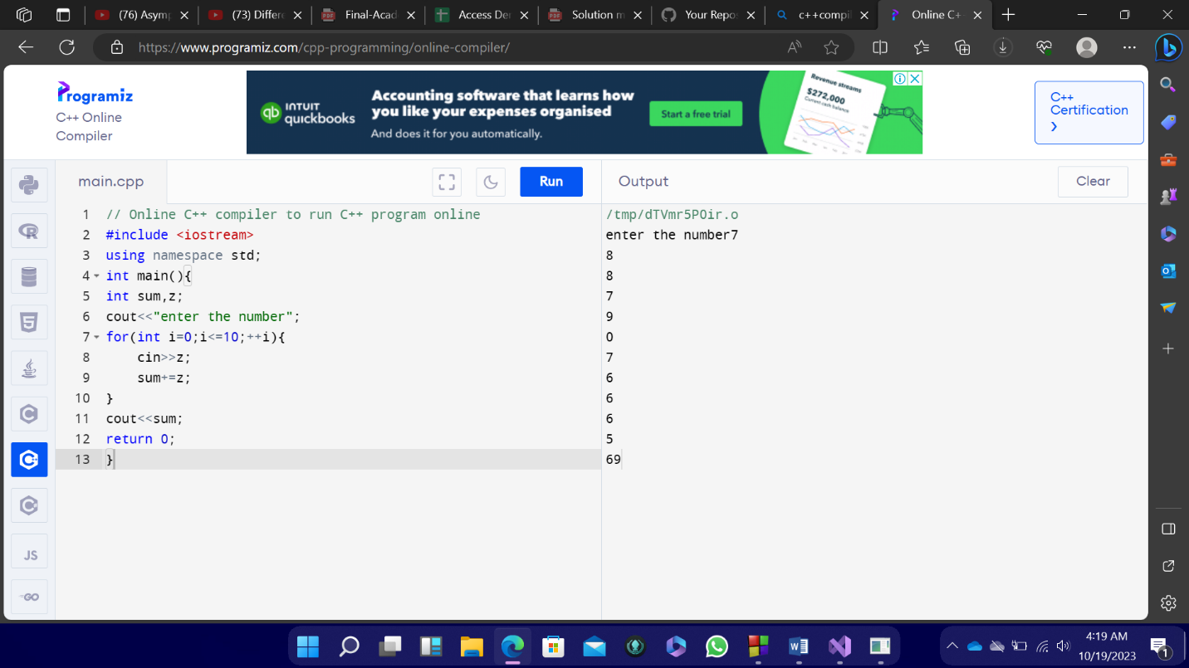

LAB TASK 2

#include<iostream>

Using namespace std

int a;

int table;

cout<<"input a number";

cin>>a;

cout <<"table of \*"<<a<<endl;

for (int i=1;i<=10;i+=1){

cout<<a<<"\*"<<i<<"="<<a\*i<<endl;

}

Return 0;

}

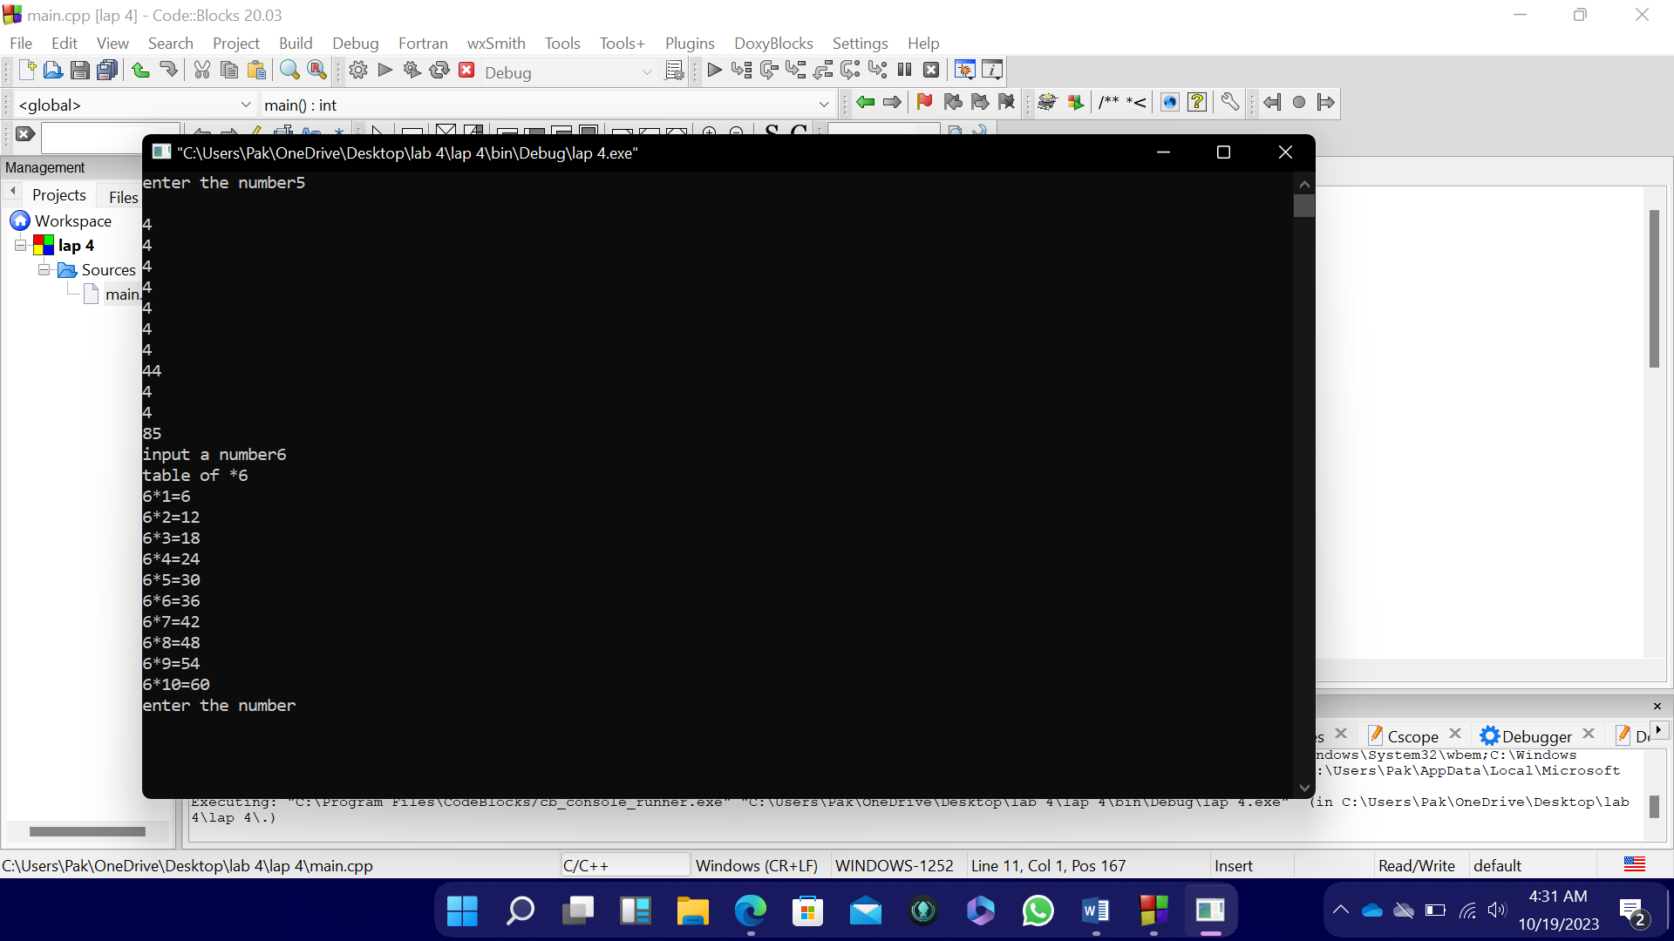

LAB TASK 3:

#include<iostream

Using namespace std;

int f,result;

cout<<"enter the number";

cin>>f;

result=f;

for(int i=f-1;i>0;i--){

result\*=i;

}

cout<<result;

return 0;

}

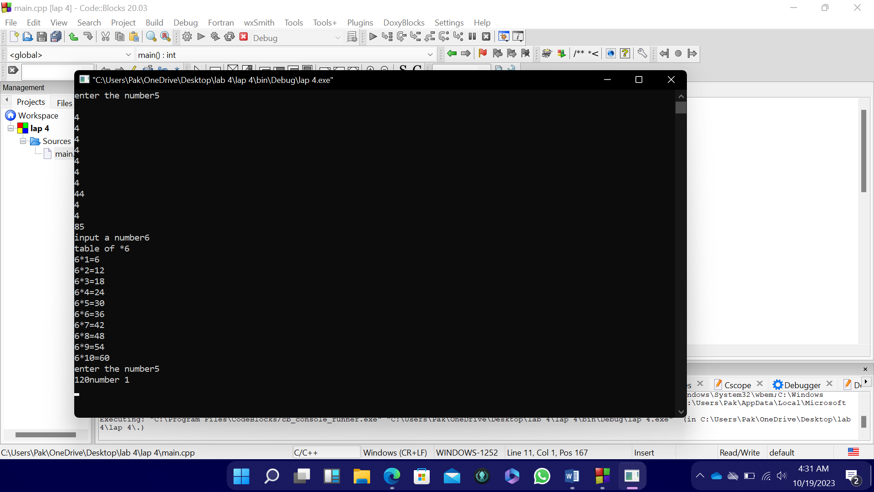

LAB TASK 4:

#include<iostream>

Using namespace std;

int x,y,pause,answer;

cout<<"number 1"<<endl;

cin>>x;

cout<<"number 2"<<endl;

cin>>y;

cout<<"pause"<<endl;

cin>>pause;

cout<<x<<",";

cout<<y<<",";

answer=x+y;

cout<<answer<<",";

for(int i=4;i<=pause;i+=1){

x=y;

y=sum;

answer=x+y;

cout<<answer<<",";

}

return 0;

}

